

Test One

Semester One 2018
UNIT 1 METHODS

Calculator Assumed 40 minutes /45 marks

Scientific Calculator, ClassPad, Formula Sheet and One page one side of A4 notes is permitted
Name:

Place a tick in the box next to your Mathematics teachers name:

Mr Strain | □
Ms Sindel | □
Ms Rimando | □
Mr Gannon | □
Mr Young | □
Mrs Flynn | □
Ms Ensly | □

Question 1 (2, 2, 2 = 6 marks)
Consider the following points, A $(4,9)$ and B $(20,12)$.
- Determine the distance from point A to B.

- Determine the midpoint between points A and B.

- If point B was the midpoint of points A and point C. Determine the coordinates of point C.

Question 2 (2, 2, 1, 3 = 8 marks)
Determine the equation of a line that passes through the point $(-10, 3)$ and :
- passes through the point $\left(5,-7\right).$

- is parallel to the line .

- is parallel to the y axis.

- is perpendicular to the line $x-4y=9.$

Question 3 (2, 3, 3 = 8 marks)
Consider the line $5x+my=21$, where is a constant.
- In terms of , determine the y intercept.

- In terms of , determine the midpoint of the x and y intercepts.

- Determine the value of so that the line will never cross $y=7x.$

Question 4 (1, 1, 2 = 4 marks)
Jessica needs to hire a car for a number of days. The hire car company has two options from which she can choose.
Budget: $15 per day plus $0.25 per km travelled
Deluxe: $42 per day for unlimited travel
i) Jessica will hire the car for n days and drive a total of x km.
a) Find an expression for the cost, $C, in terms of n for the Deluxe option.

b) Find an expression for the cost, $C, in terms of n and x, for the Budget option.

ii) If Jessica plans to drive a total of 600 km, find the maximum number of days for which she can hire the car so that it is cheaper for her to take the Deluxe option.

Question 5 (2, 2, 2 = 6 marks)
Factorise the following expressions:
- $4x^{2}y-12xy^{4}$

- $x^{3}-3x^{2}-9x+27$

- $18x^{2}+33x-30$

Question 6 (5 marks)
On the axes below, sketch the parabola $y=-2{\left(x+3\right)}^{2}+6$ showing all major features.

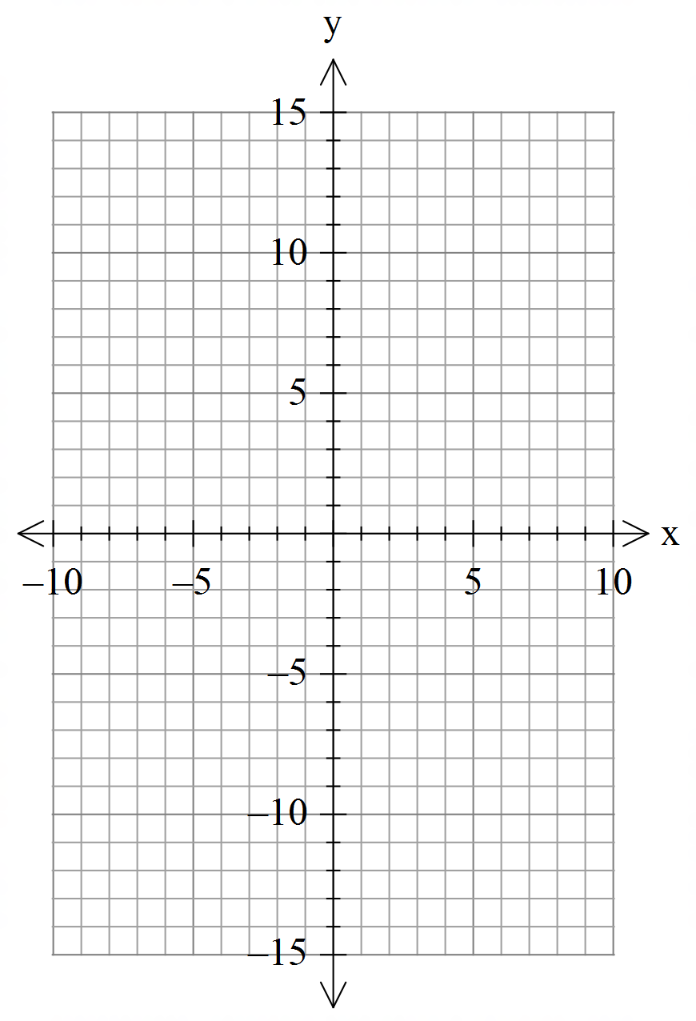

Question 7 (2, 2 =4 marks)
For each of the following write down the equation of a parabola that satisfies the following:
(No need to simplify)
- A quadratic with intercepts $\left(4,0\right)$and $(-7,0)$ with a y intercept of (0, -56).

- A quadratic with a maximum turning point $(7,1)$ and an $x$ intercept $\left(10,0\right).$

Question 8 (4 marks)
Determine the value of for the shape below.
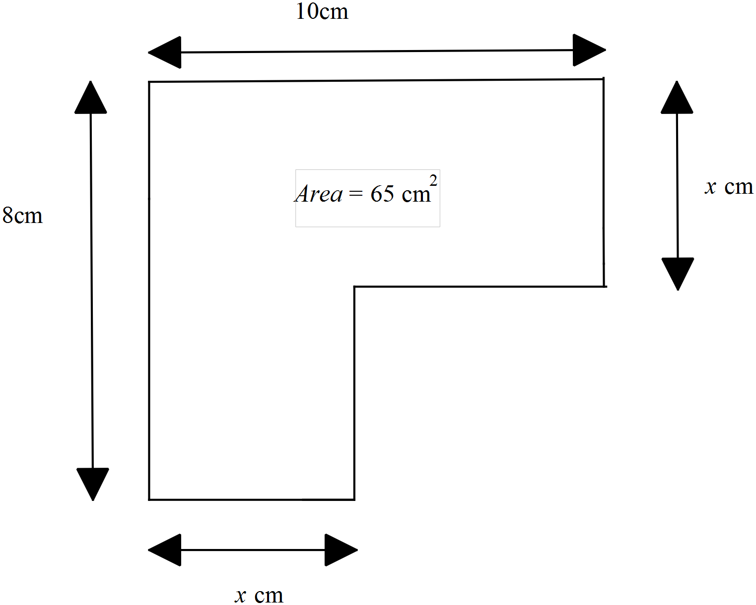

End of test

